**Car Sorting System**

**Aim: -**

To create a program for a car sorting system based on price of the car.

**Research: -**

In modern times, businesses are required to have properly sorted system and distribution channels due to vast increase in consumerism.

Thus, businesses need properly sorted databases that contain inventory of their goods, specifications for the various items, records of sales, customer buying patterns etc. to maximize the efficiency of the business while promoting its growth and increasing profits.

For example, in the automobile industry, businesses need to have inventory for what all car models are present in the showroom, how many cars of each model have been sold, which car is being bought the most etc.

For this, a car system is needed.

**Analysis: -**

A system that sorts cars based on their price is essentially a car inventory management or e-commerce platform with a specific sorting functionality.

This type of system is a common feature on websites like car dealerships, classified ads (e.g., Craigslist, Autotrader), and automotive review sites

**Ideate: -**

The code contains of various tools from C-Programming such as arrays, structures.

In the code, initially the structure is declared that is used the parameters such as name of the car, its model id and its price.

Then input is accepted from the user for the no. of cars to be taken as entry.

Based on the no. of cars, a for loop is used to take entry for the parameters.

Then bubble sort algorithm is used to sort the input values in descending order.

Then the sorted details are displayed in a tabular format.

**Build: -**

#include<stdio.h>

struct car

{

int model_id, price;

char model_name[30];

};

int main()

{

int n,i,j;

struct car C[i], temp;

printf("Enter no. of cars: ");

scanf("%d", &n);

for(i=0;i<n;i++)

{

printf("\nEnter name of the car: ");

scanf("%s", &C[i].model_name);

printf("Enter car model id: ");

scanf("%d", &C[i].model_id);

printf("Enter price of the car: ");

scanf("%d", &C[i].price);

}

for(i=0;i<n-1;i++)

{

for(j=i+1;j<n;j++)

{

if(C[i].price<C[j].price)

{

temp=C[i];

C[i]=C[j];

C[j]=temp;

}

else if(C[i].price=C[j].price)

{

if(C[i].model_id>C[j].model_id)

{

temp=C[i];

C[i]=C[j];

C[j]=temp;

}

}

}

}

printf("\n-------Car Details-------\n");

for(i=0;i<n;i++)

{

printf("Name: %s |\n", C[i].model_name);

printf("ID: %d |\n", C[i].model_id);

printf("Price: %d |\n", C[i].price);

printf("-----------------------\n");

}

return 0;

}

**Testing: -**

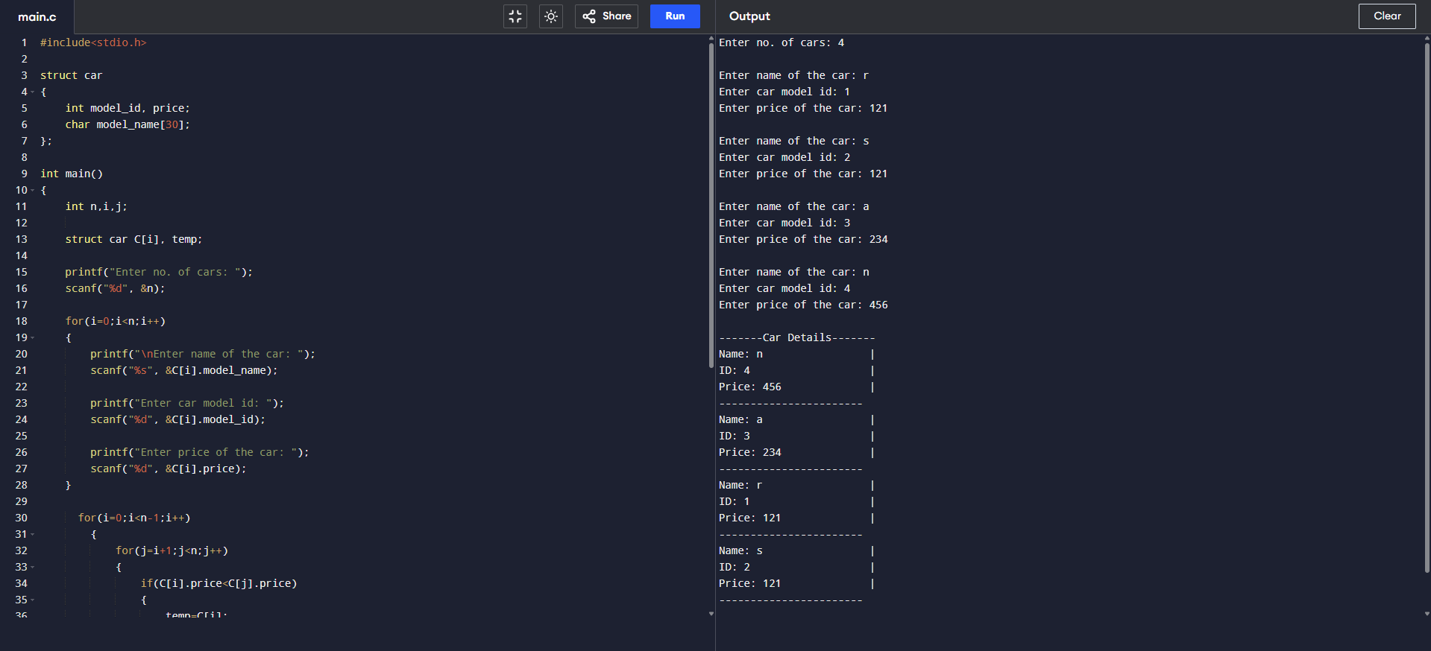

**Implementation: -**

**Conclusion: -**

Thus, this report provides the code and details regarding a car sorting system based on the price, thus achieving our objective.